SQL Tutorial

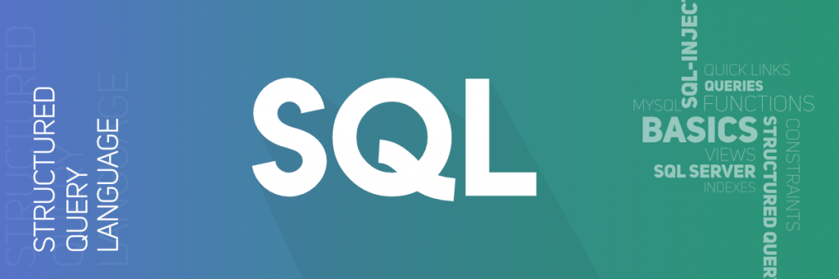

**S**tructured **Q**uery **L**anguage or **SQL** is a standard Database language which is used to create, maintain and retrieve the data from relational databases like MySQL, Oracle, SQL Server, PostGre, etc. The recent ISO standard version of SQL is SQL:2019.

As the name suggests, it is used when we have structured data (in the form of tables). All databases that are not relational (or do not use fixed structure tables to store data) and therefore do not use SQL, are called NoSQL databases. Examples of NoSQL are MongoDB, DynamoDB, Cassandra, etc

[**‘Recent Articles’ on SQL**](https://www.geeksforgeeks.org/tag/sql/)

**Topic:**

* [Basics](https://www.geeksforgeeks.org/sql-tutorial/#basics)
* [Clauses / Operators](https://www.geeksforgeeks.org/sql-tutorial/#clause)
* [Functions](https://www.geeksforgeeks.org/sql-tutorial/#function)
* [Queries](https://www.geeksforgeeks.org/sql-tutorial/#queries)
* [SQL-Injection](https://www.geeksforgeeks.org/sql-tutorial/#sql-injection)
* [PL/SQL](https://www.geeksforgeeks.org/sql-tutorial/#pl-sql)
* [MySQL](https://www.geeksforgeeks.org/sql-tutorial/#mysql)
* [SQL Server](https://www.geeksforgeeks.org/sql-tutorial/#sql-server)
* [Misc](https://www.geeksforgeeks.org/sql-tutorial/#misc)
* [Quick Links](https://www.geeksforgeeks.org/sql-tutorial/#quick-link)

**Basics:**

* [Structured Query Language](https://www.geeksforgeeks.org/structured-query-language/)
* [SQL | Datatypes](https://www.geeksforgeeks.org/sql-datatypes/)
* [SQL | DDL, DML, TCL and DCL](https://www.geeksforgeeks.org/sql-ddl-dml-tcl-dcl/)
* [SQL | TRANSACTIONS](https://www.geeksforgeeks.org/sql-transactions/)
* [SQL | VIEWS](https://www.geeksforgeeks.org/sql-views/)
* [SQL | Comments](https://www.geeksforgeeks.org/sql-comments/)
* [SQL | Constraints](https://www.geeksforgeeks.org/sql-constraints/)
* [SQL | Creating Roles](https://www.geeksforgeeks.org/sql-creating-roles/)
* [SQL | Indexes](https://www.geeksforgeeks.org/sql-indexes/)
* [SQL | SEQUENCES](https://www.geeksforgeeks.org/sql-sequences/)
* [SQL | Query Processing](https://www.geeksforgeeks.org/sql-query-processing/)
* [CTE in SQL](https://www.geeksforgeeks.org/cte-in-sql/)
* [SQL Trigger | Student Database](https://www.geeksforgeeks.org/sql-trigger-student-database/)
* [Book Management Database](https://www.geeksforgeeks.org/sql-trigger-book-management-database/)
* [Introduction to NoSQL](https://www.geeksforgeeks.org/introduction-to-nosql/)